Konica Minolta Chromameter Guide

Nathalie Rusu Sirbu

1. The contents of the box

USBs

Granular attachment

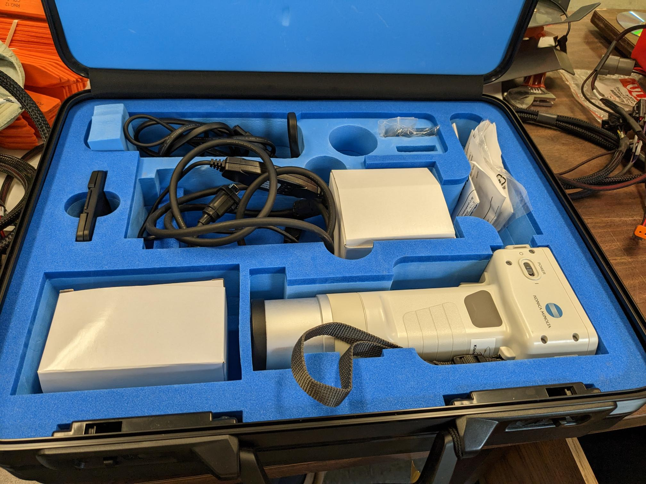

RS-232C cable

White calibration plate

External AC adapter

User manual

Chromameter

2. Setting up the software

* There are two USBs: one is to download the software, the other one is the key to access it once it’s downloaded

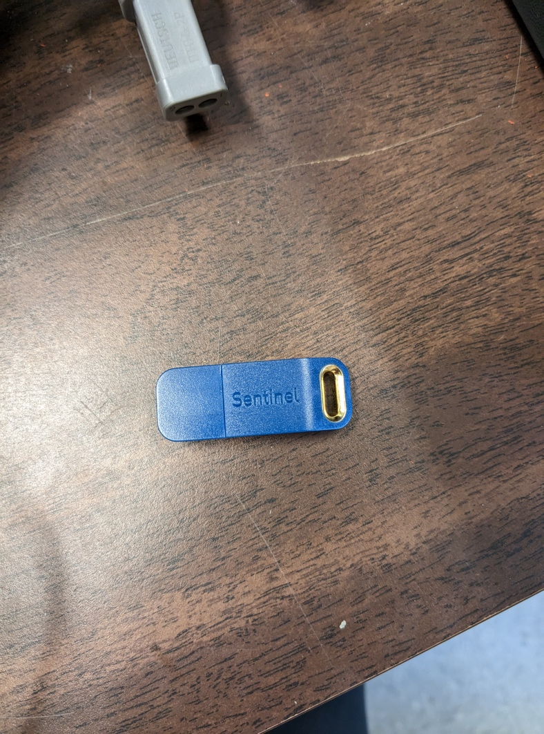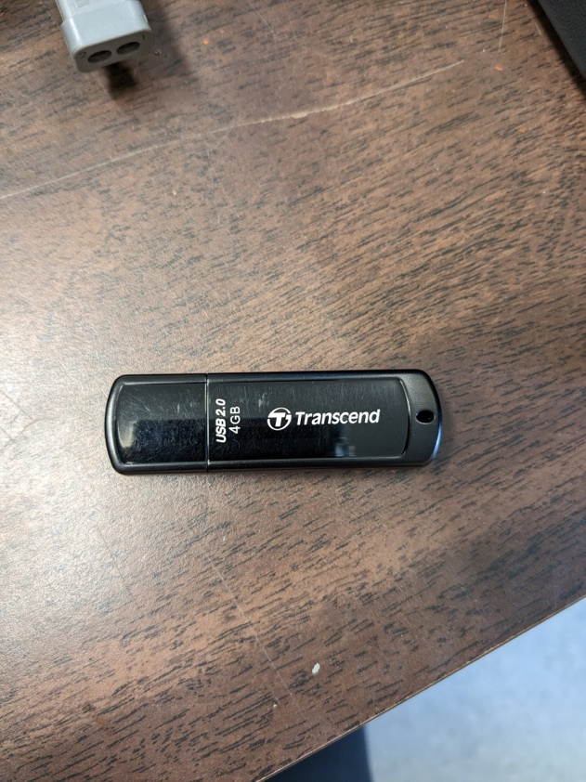

The USB needed to access the software (used at all times)

The USB needed to download the software (one time use per computer)

* To be able to create and measure data, the blue USB needs to be plugged in to the computer at all times:

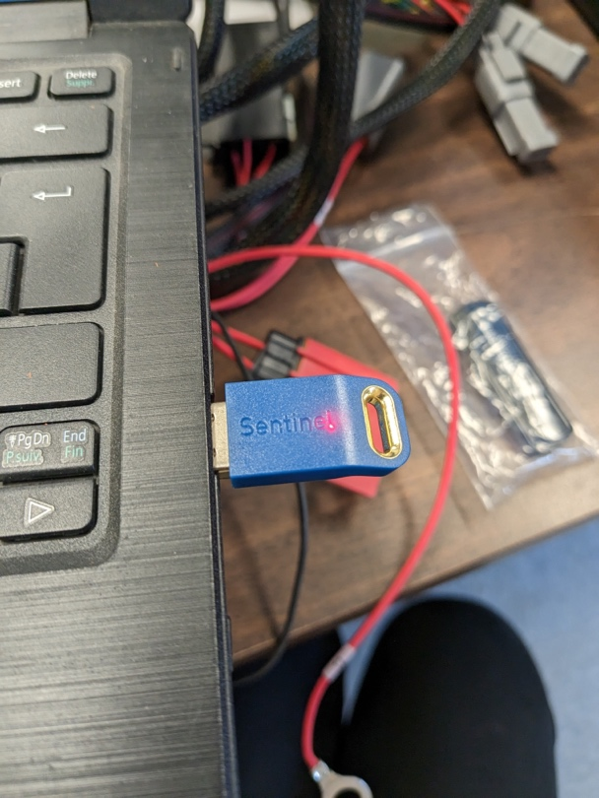

3. Navigating the software

* 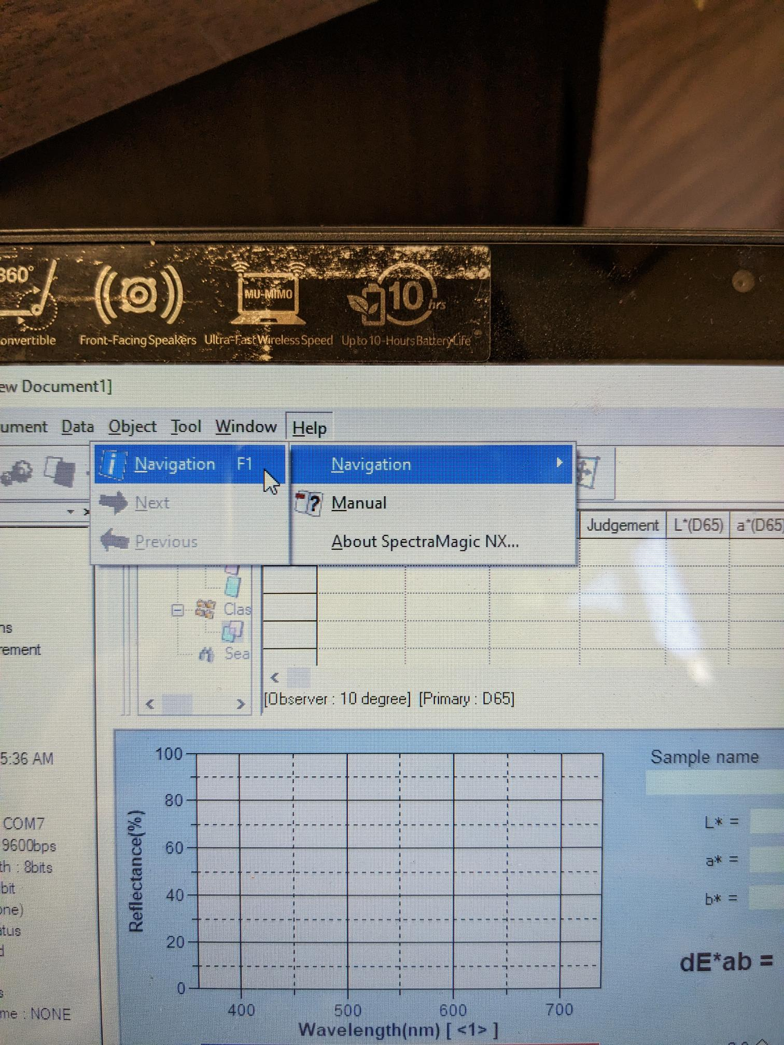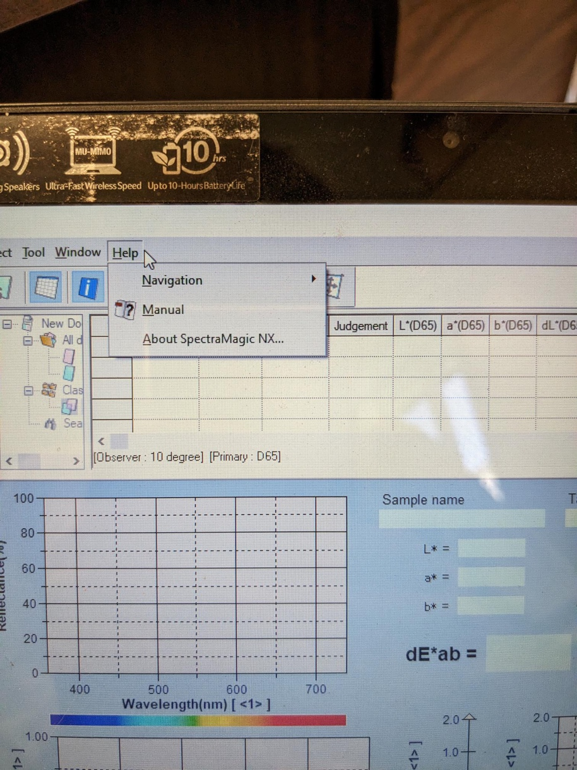There is already a comprehensive navigation guide provided with the software. Normally it is already open, but to find it again: Help > Navigation > Navigation.
* 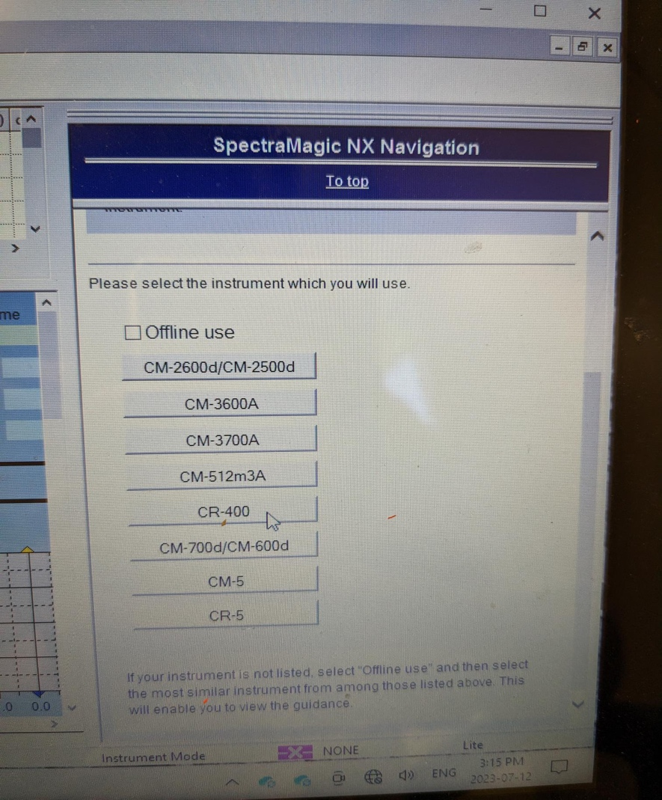From here, you select which instrument you are using: **CR-400**
* 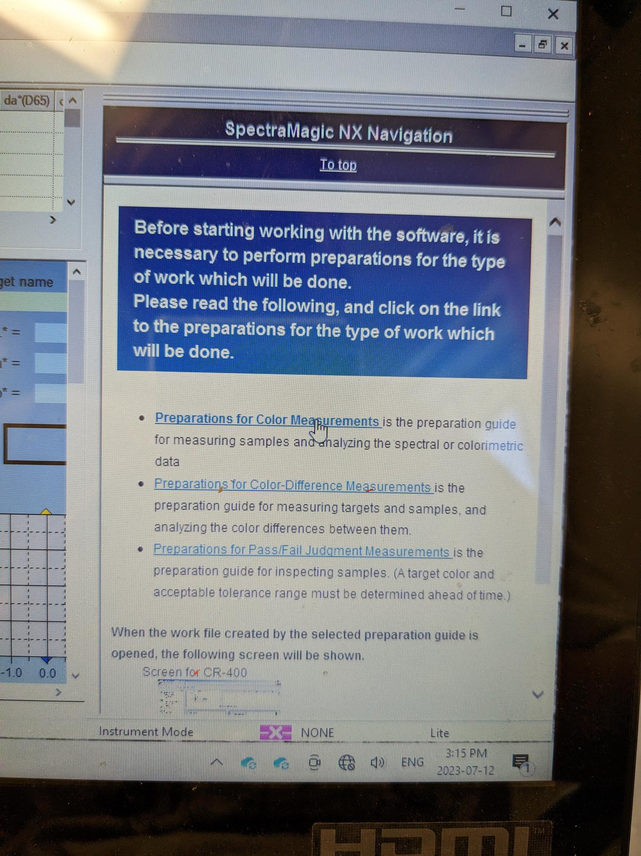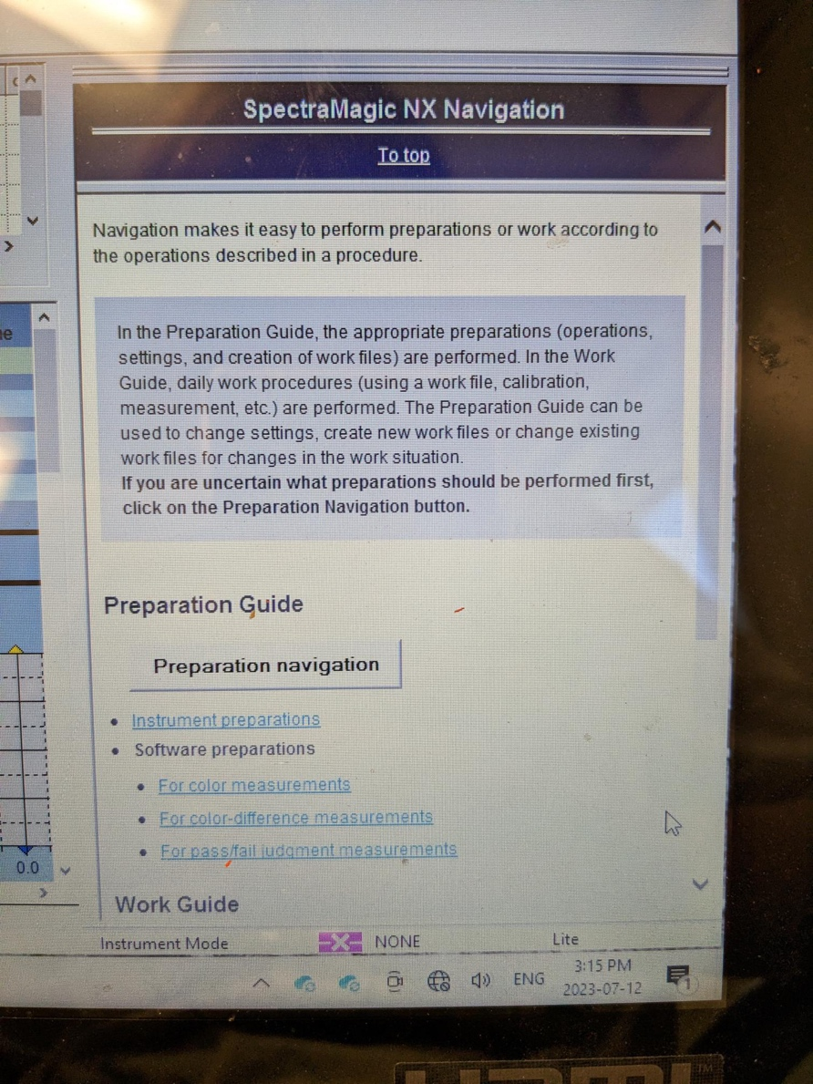Once the instrument is selected, you can now go through preparation navigation > preparation for color measurements.

4. Preparing the instrument

* Once the preparation navigation has been selected, the instructions are easy to follow.

Note: The first step of the preparation is connecting the AC adaptor. However, we have found that if we connect it, the chromameter is no longer able to measure data, therefore we skip this step. Since we connect the RS-232C cable in a later step, every individual measurement taken is transferred to the computer as it’s being measured, so there is no risk of losing data.

* 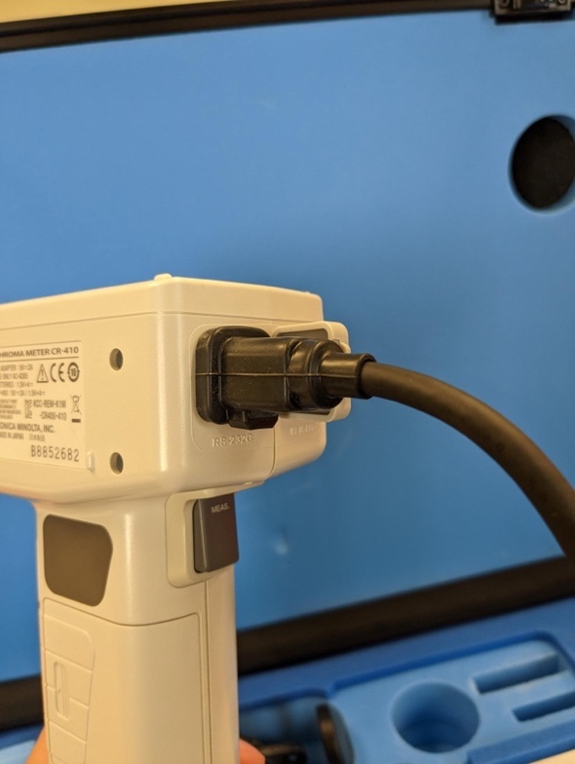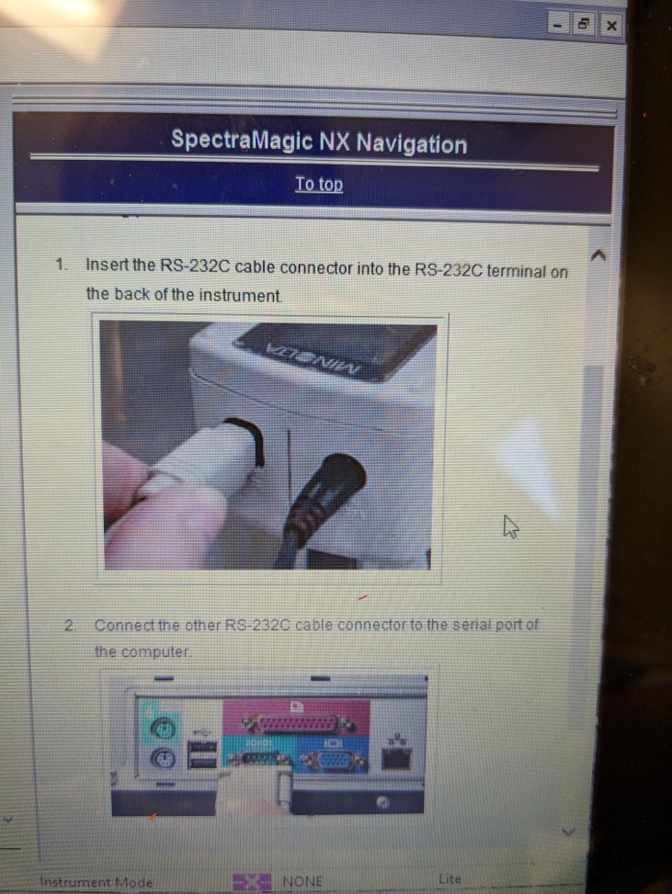Moving on to the next part of preparations:
* 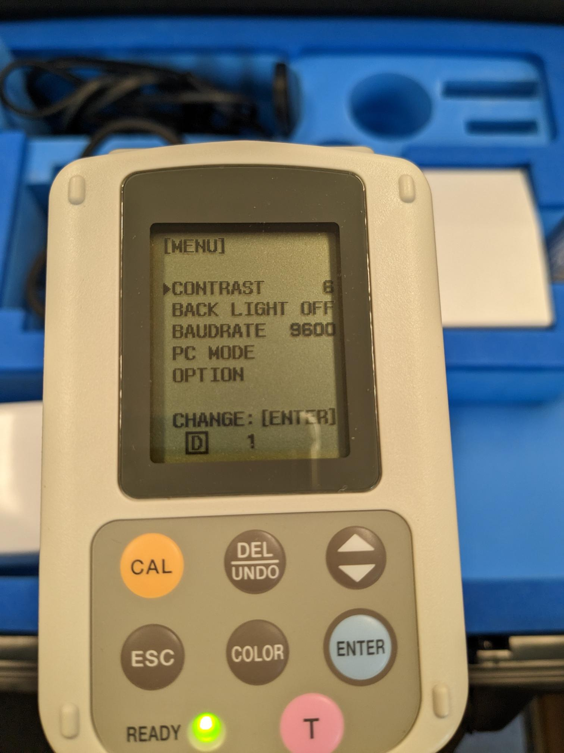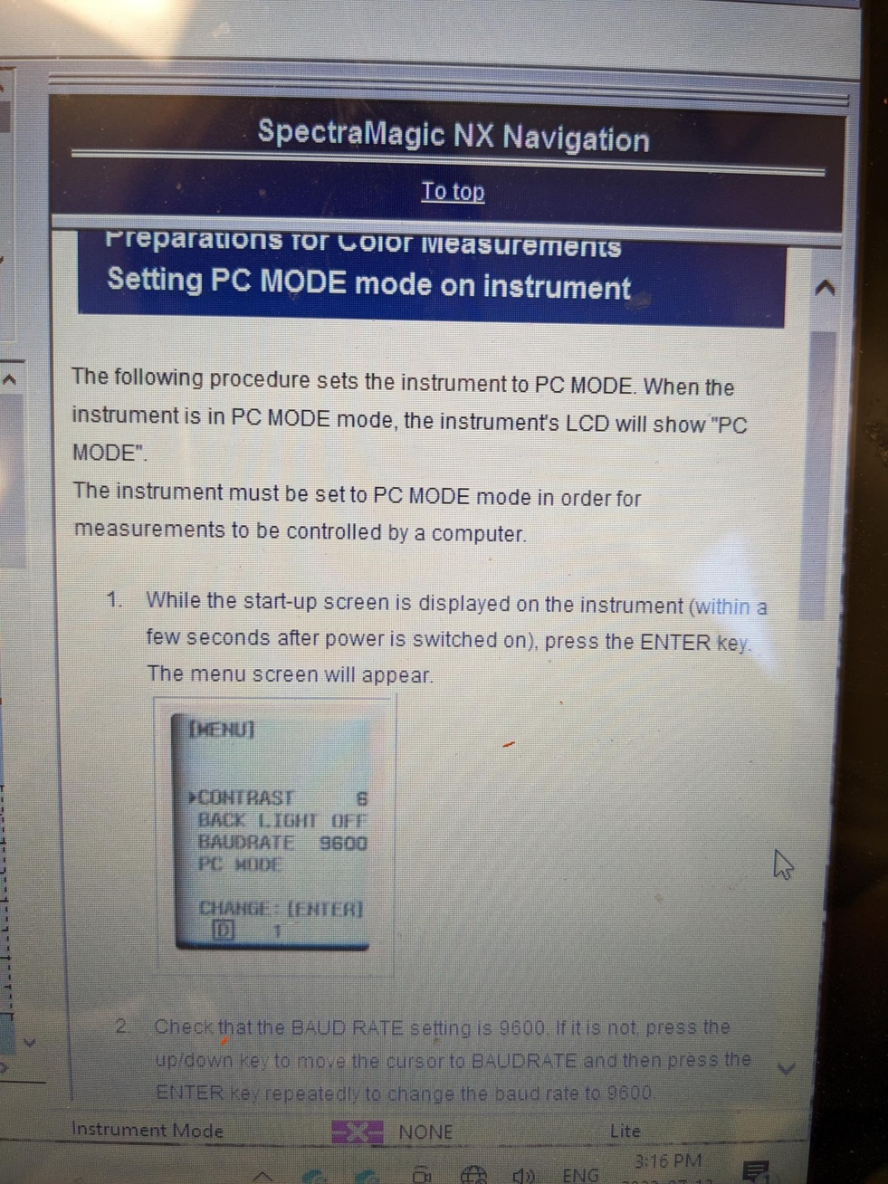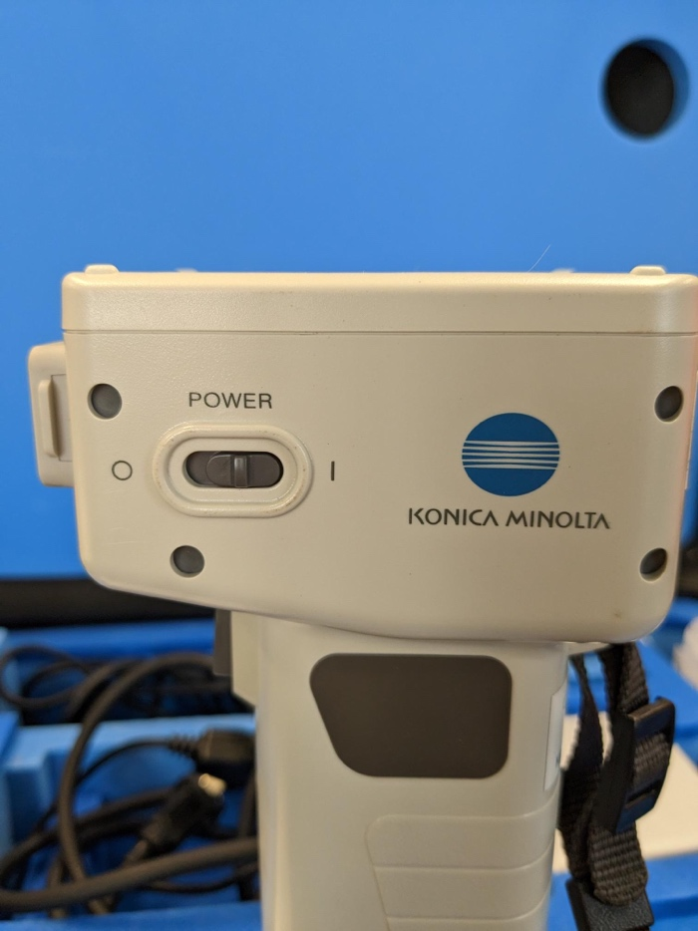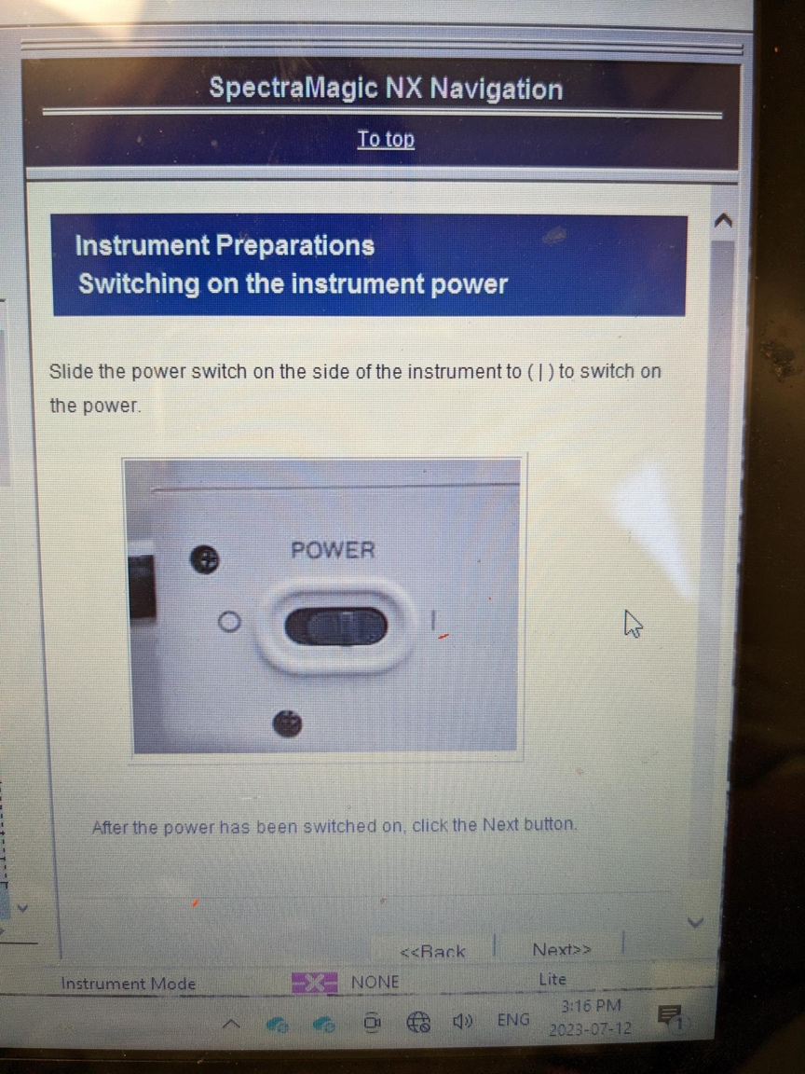Once the RS-232C cable is connected (make sure you hear the click of the cable once it’s pushed all the way in), we can turn the instrument on and set it to PC mode:
* “Enter” needs to be pressed very quickly after the instrument is turned on in order to access the menu.
* 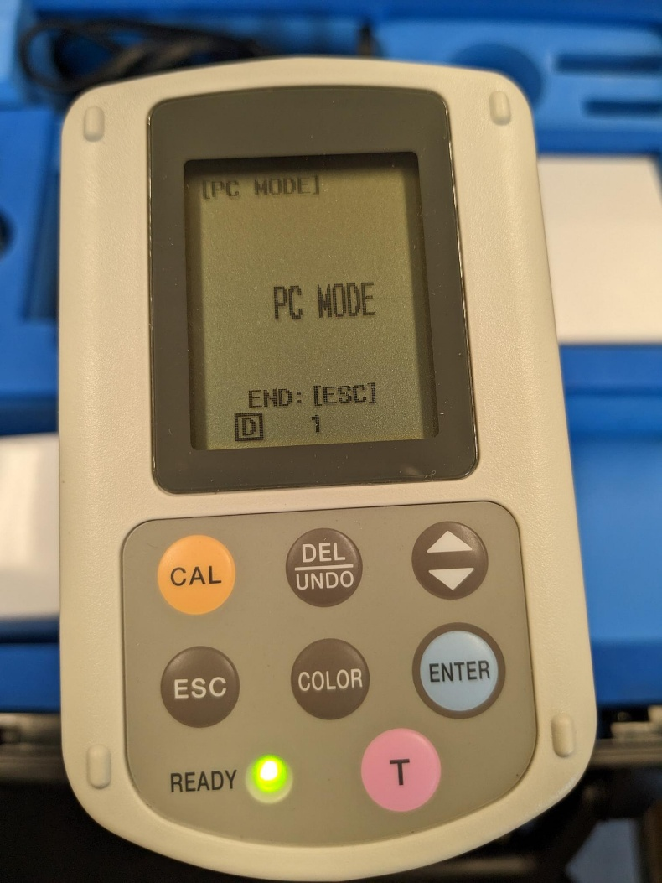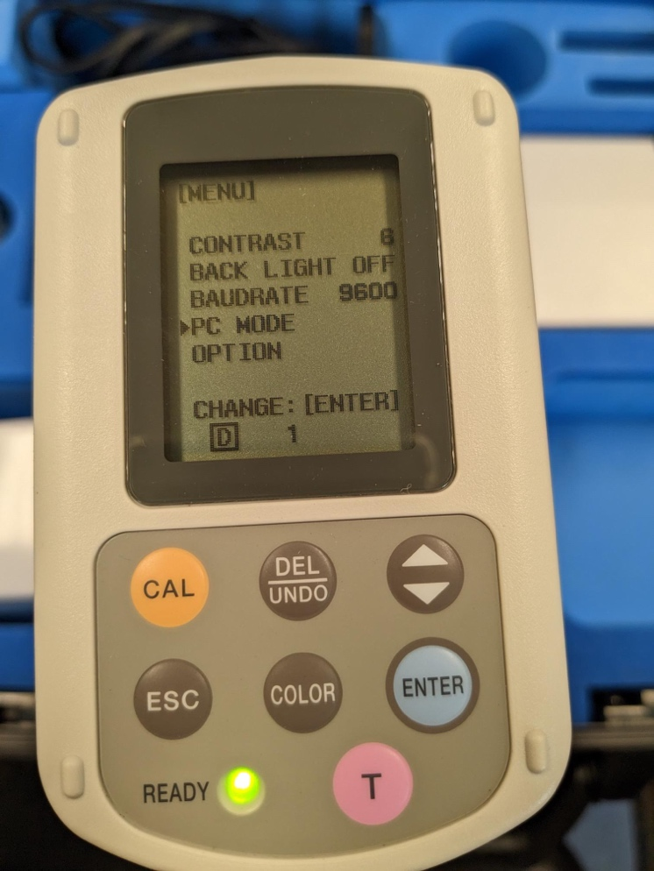To select PC mode, use the arrows to navigate the screen then press ENTER to select.
* 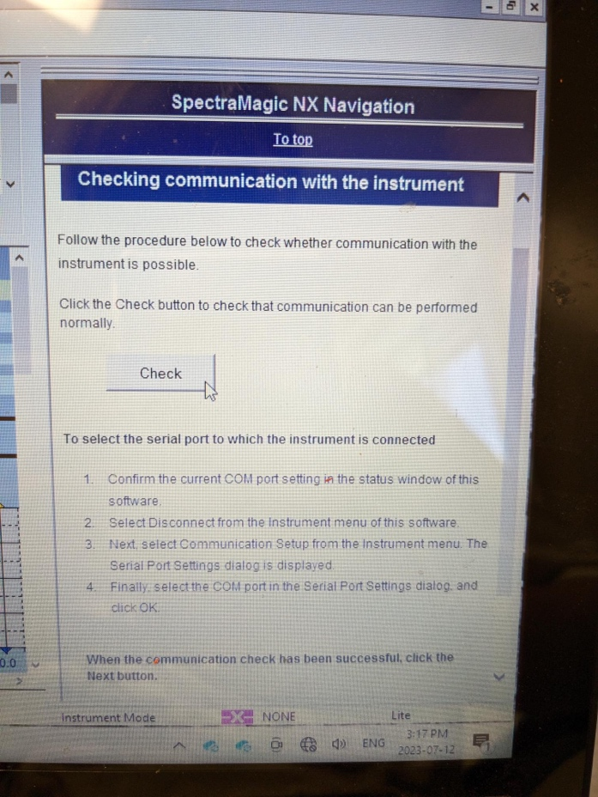Once the cable has been connected and PC mode has been selected, you can check if the instrument is connected properly by confirming that the application can communicate with the instrument:

5. White plate calibration

* Before taking any measurements, the instrument needs to be calibrated with the white plate so that the instrument can work compared to a standard and in a specific range.
* White calibration should be performed once every day, before taking measurements.
* 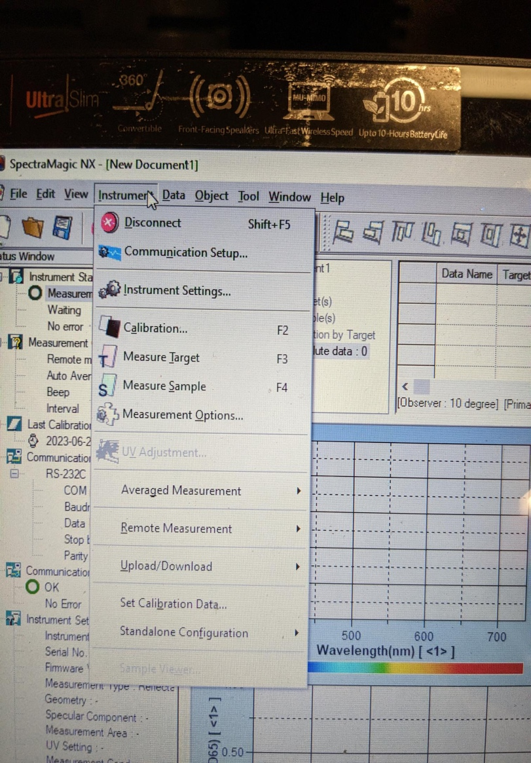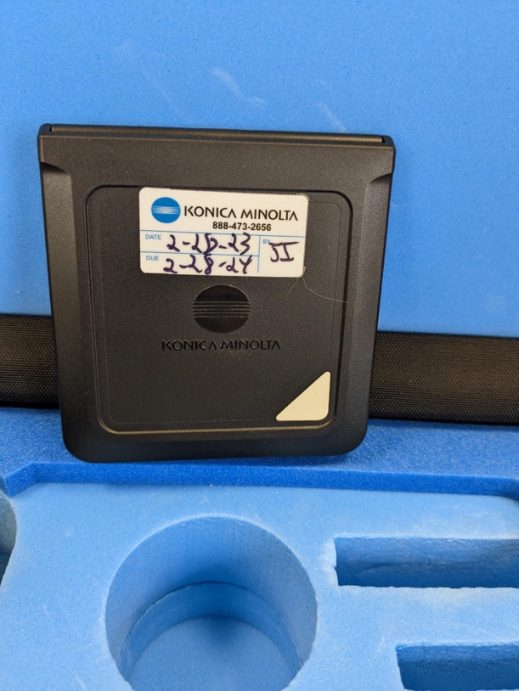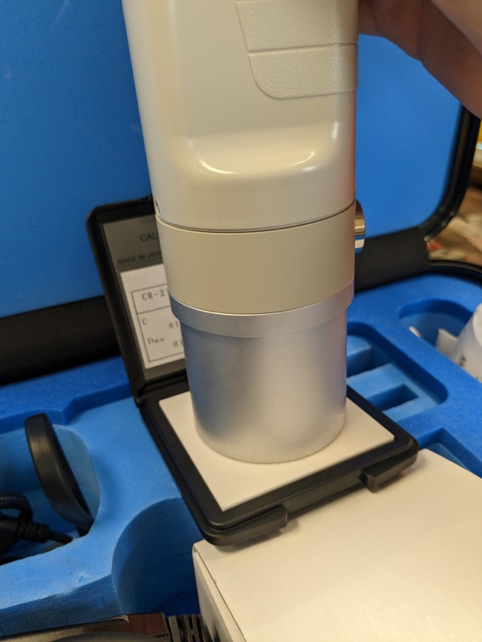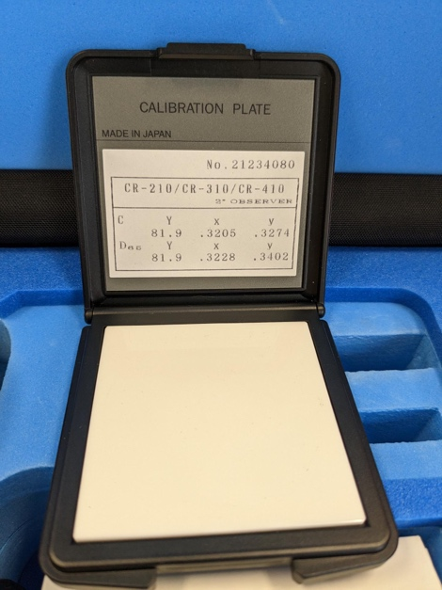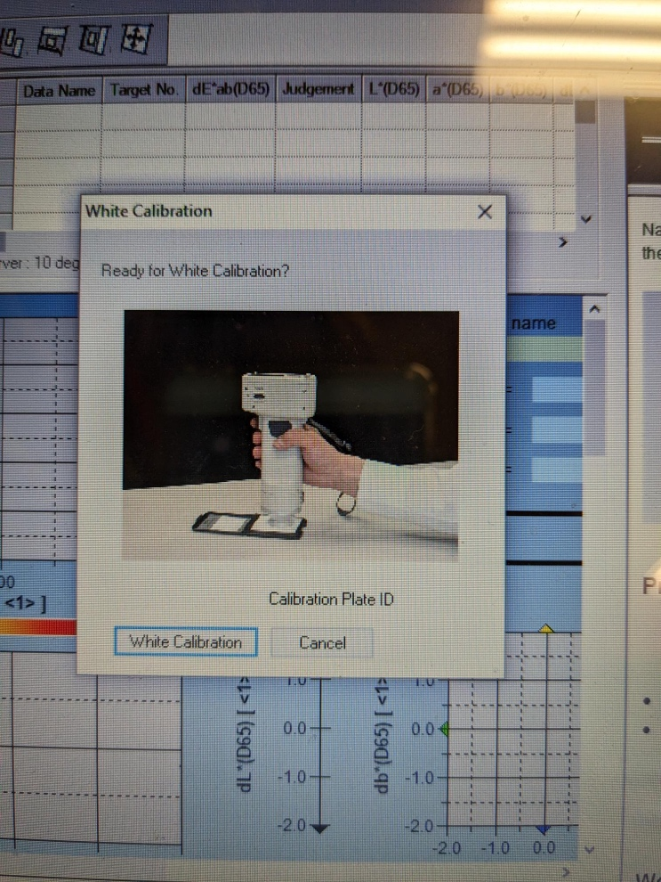The option to do white calibration should appear once “check” is pressed in the previous step, or it can be accessed through the top menu:

6. Observer and Illuminant

* 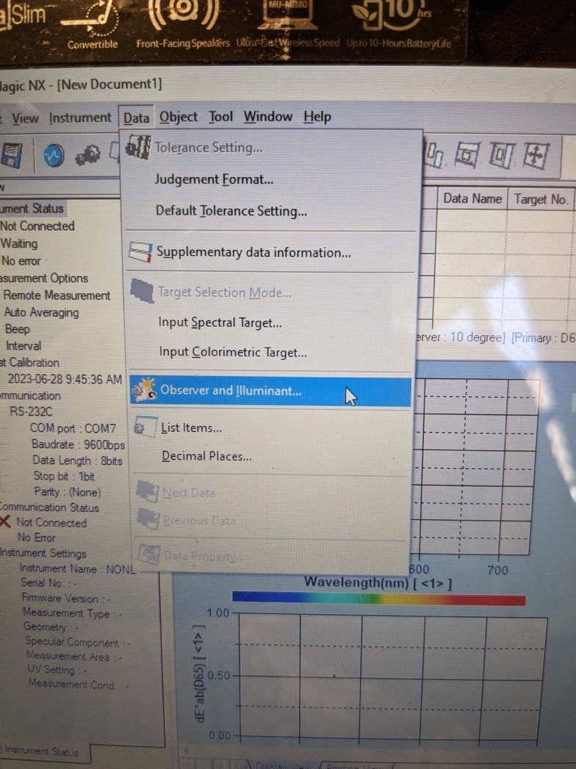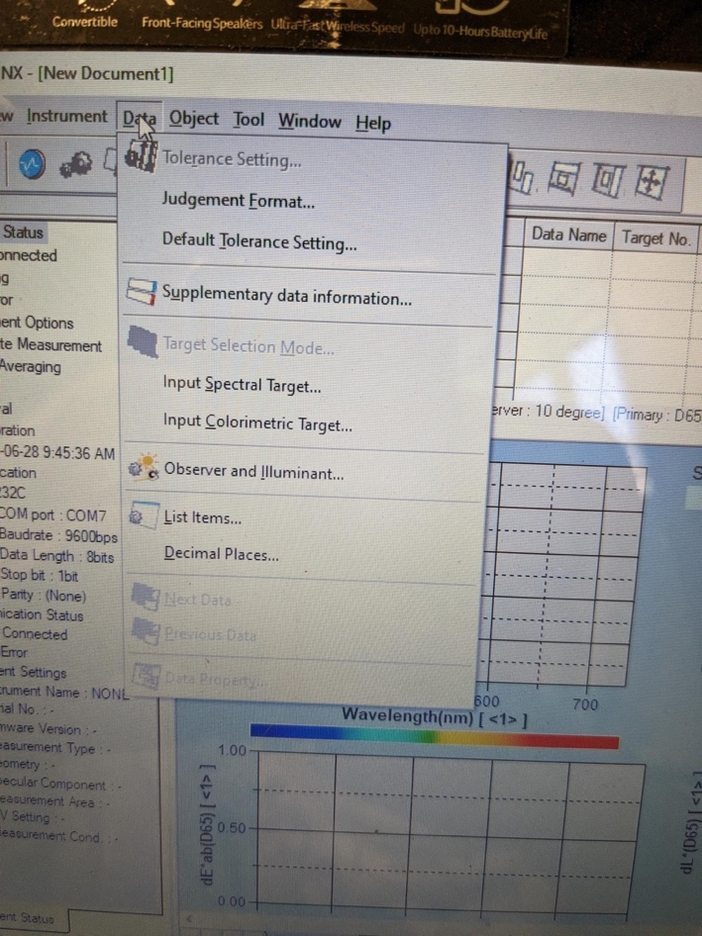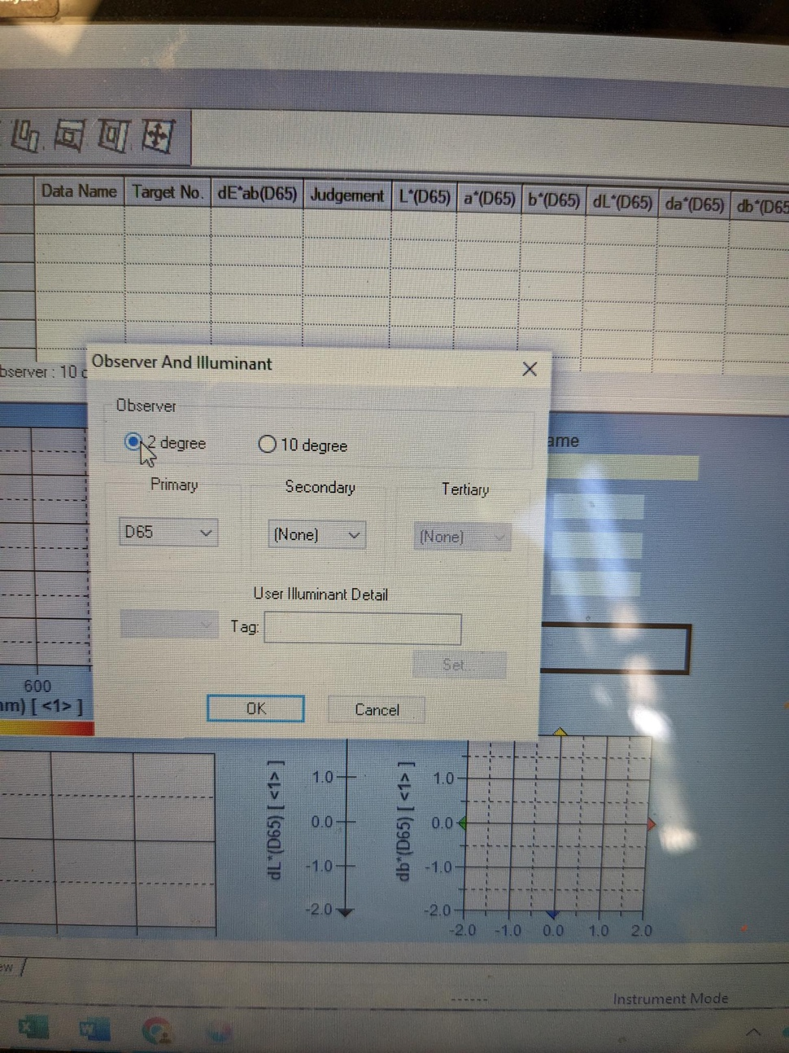Before measurements can be taken, the observer and the illuminant need to match. In order to do this, you can access “observer and illuminant” from the top menu: Data > Observer and Illuminant. Then, change the observer from 10 degree to 2 degree (as it says on the white calibration plate).
* Once this is set up, it can be saved as a template: File>Template>Save as, although there is already a template saved on our laptop, and once you start inputting data you will not need to change the observer again.

7. Setting up your sample

* To set up the sample (beans), you need to put them in the granular attachment
* The sample can’t be too big, since the lid needs to be screwed on tightly and you don’t want to risk scratching the glass, and the sample should be free of split or dirty beans.
* Before you start taking measurements also make sure that the samples are ordered by plot so that they stay in the right order when getting measured.

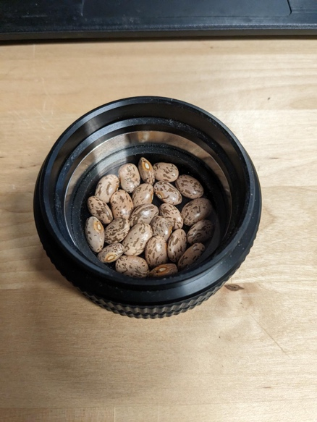

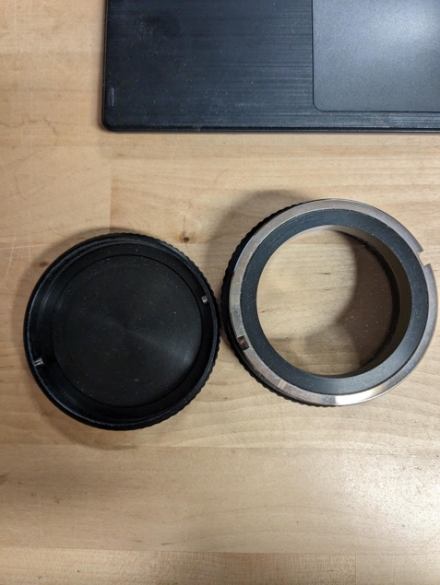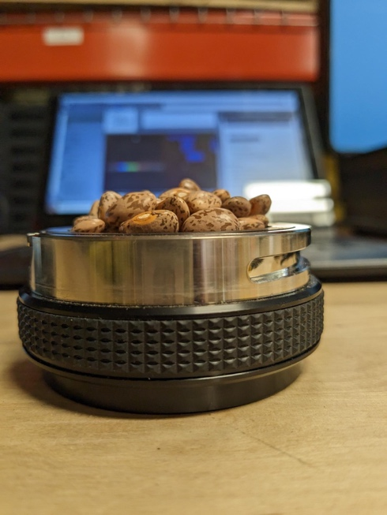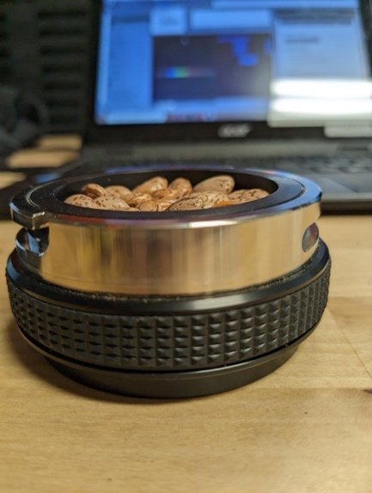

Just right

Too much!

8. Taking measurements

* 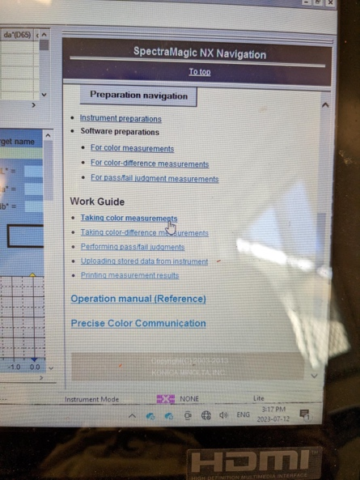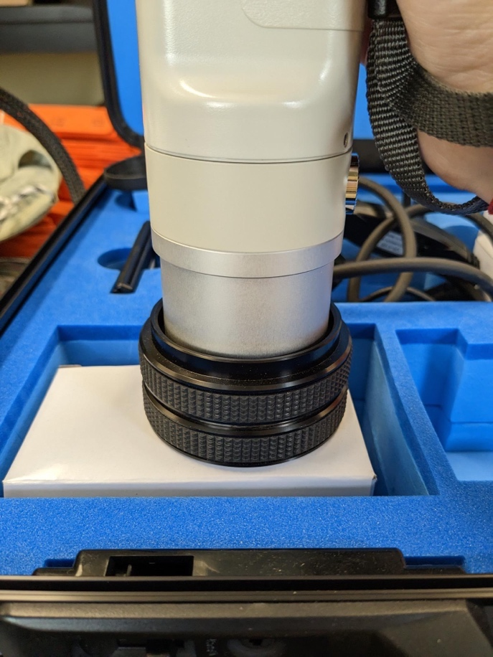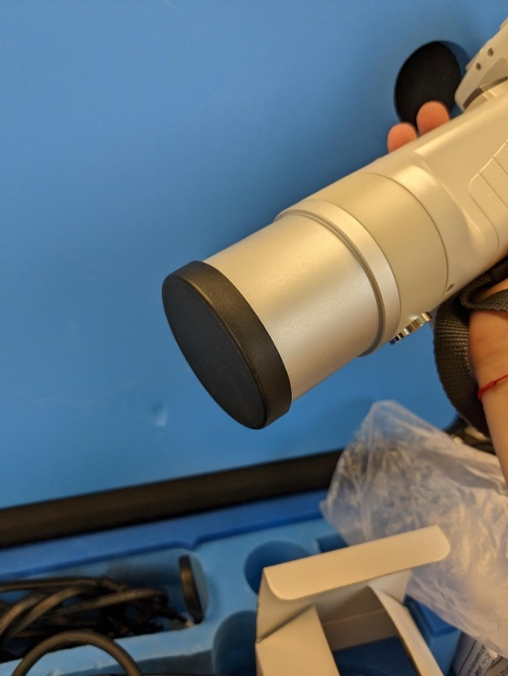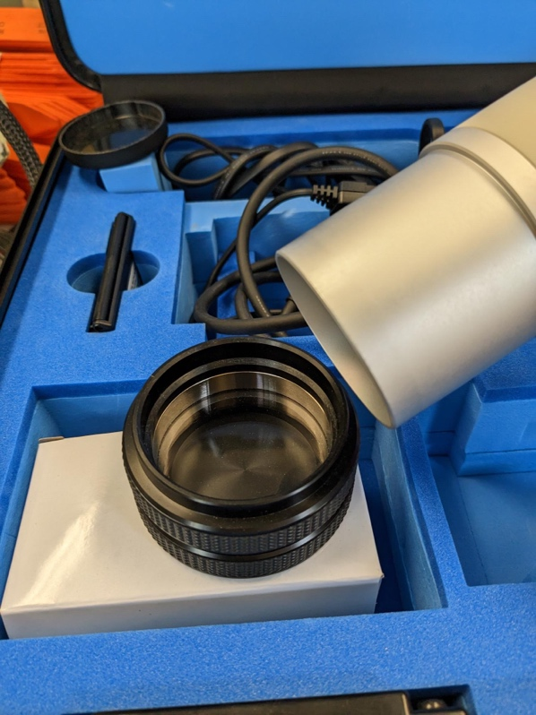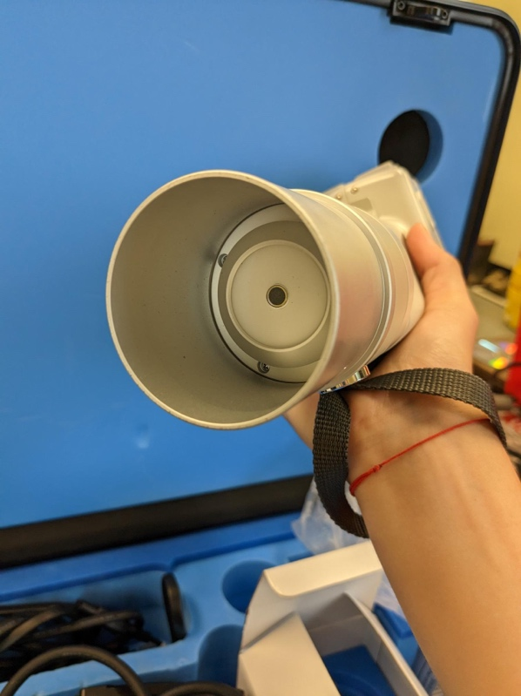To use the instrument, the cover needs to be taken off and the instrument needs to be placed in the granular attachment.

Do not look into the instrument as it’s taking a measurement!

Make sure the strap is around your wrist when using the instrument!

* 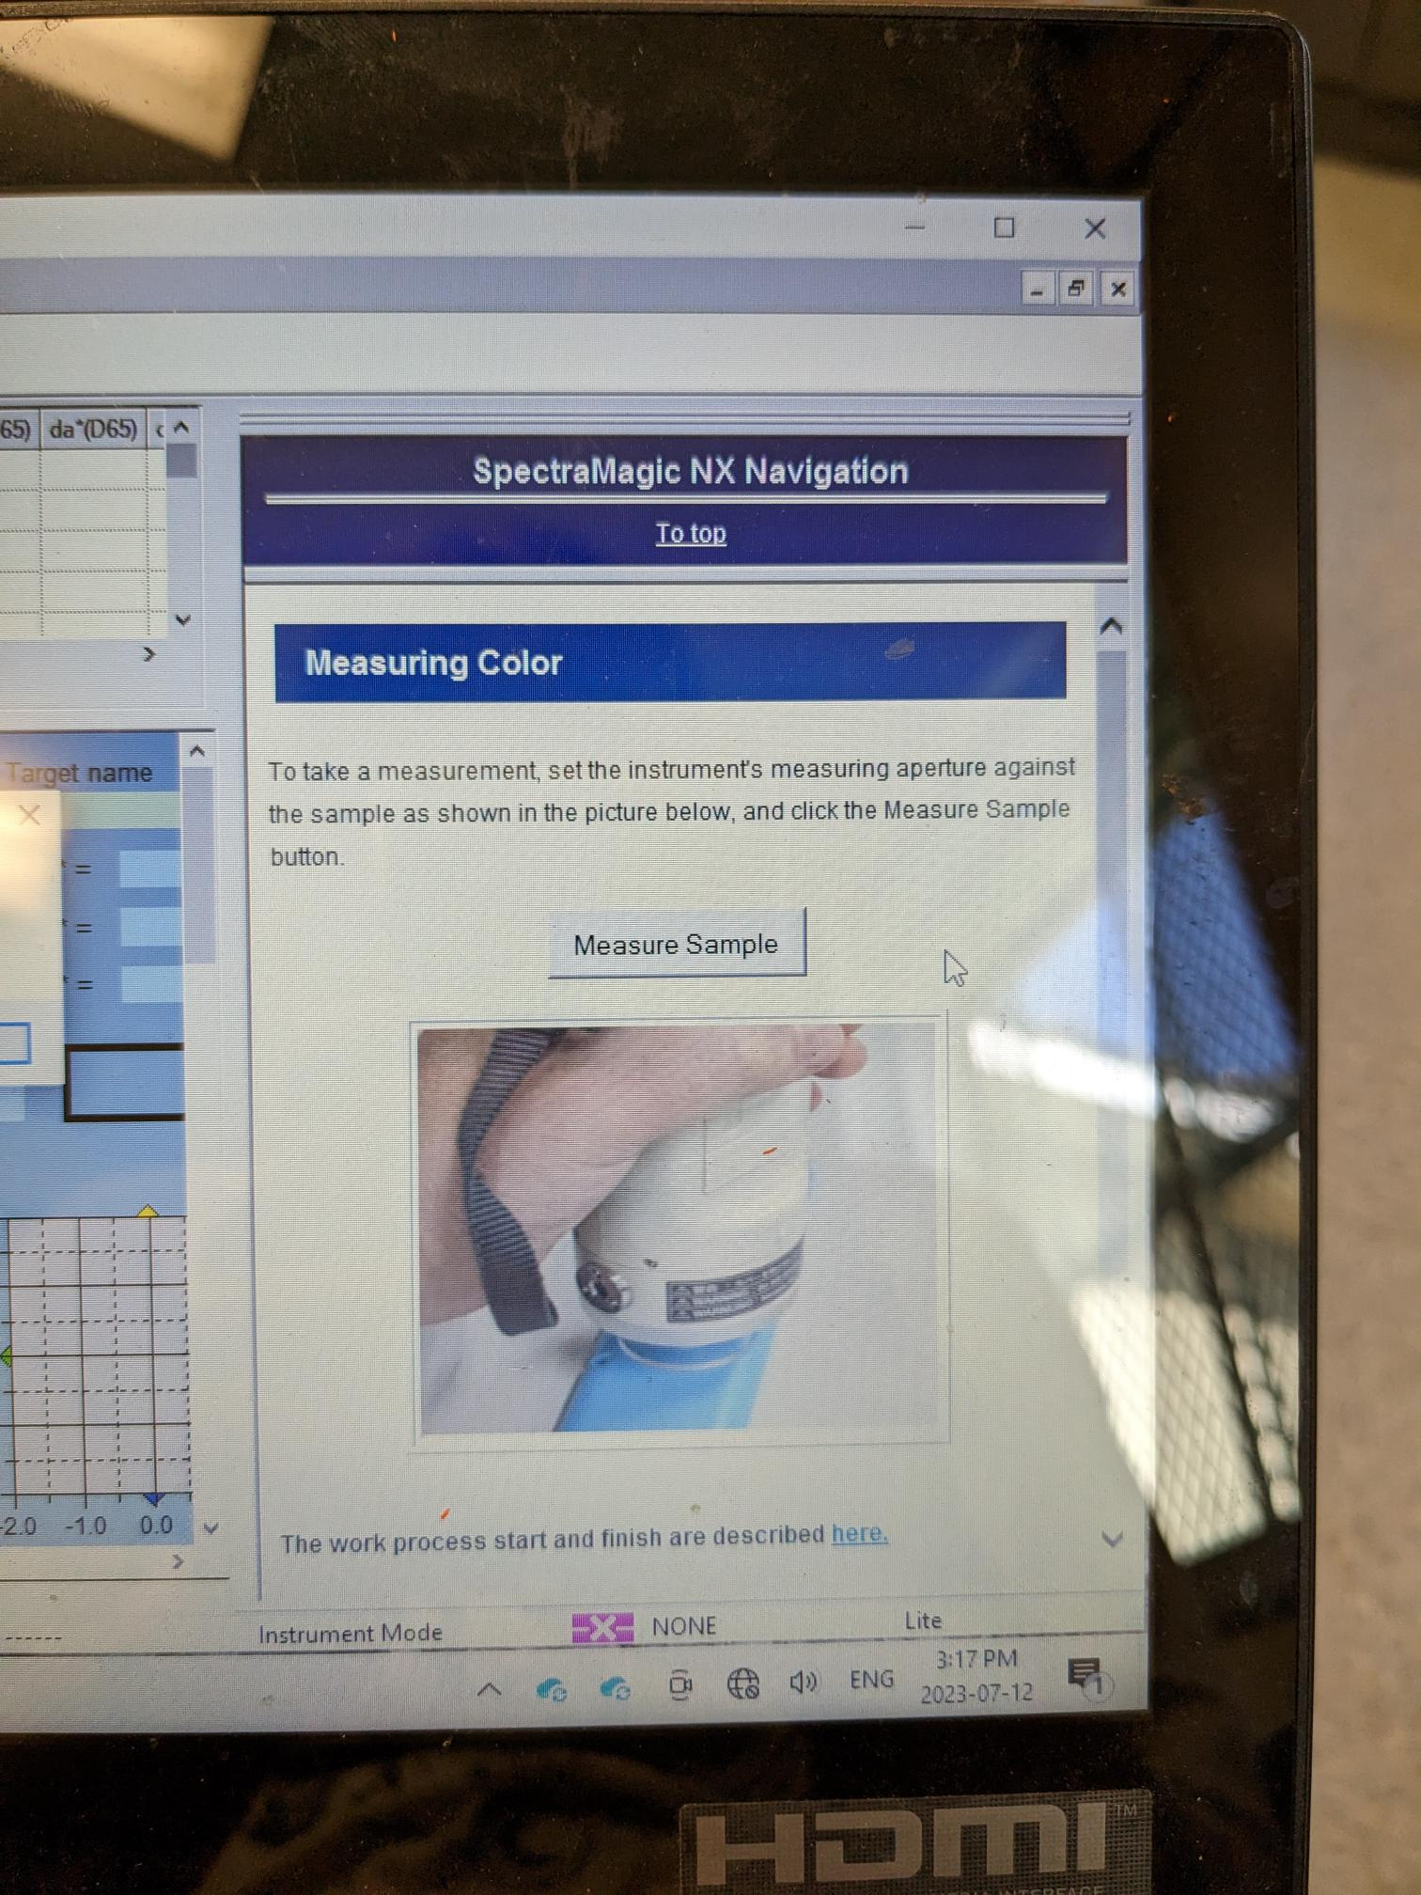Once everything is set up, you can begin taking measurements while being connected to the computer by once again going to navigation and clicking “taking color measurements” (this can be found under “preparation navigation” from step 3)
* 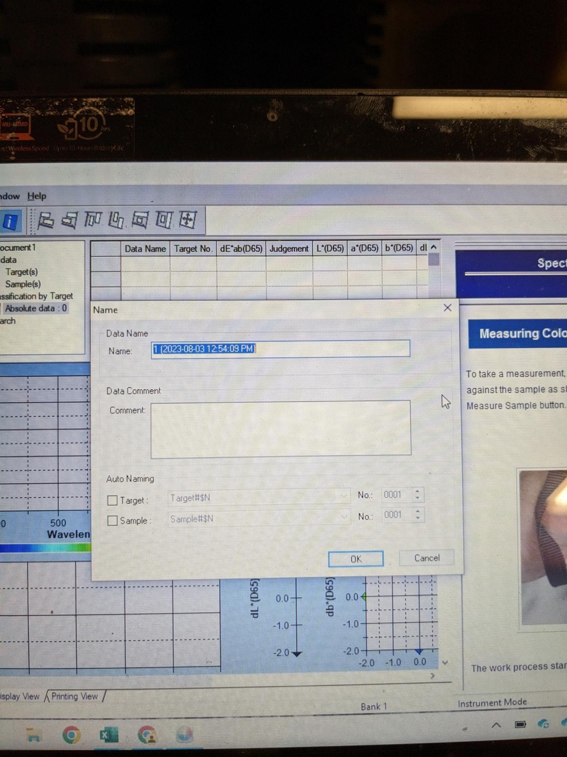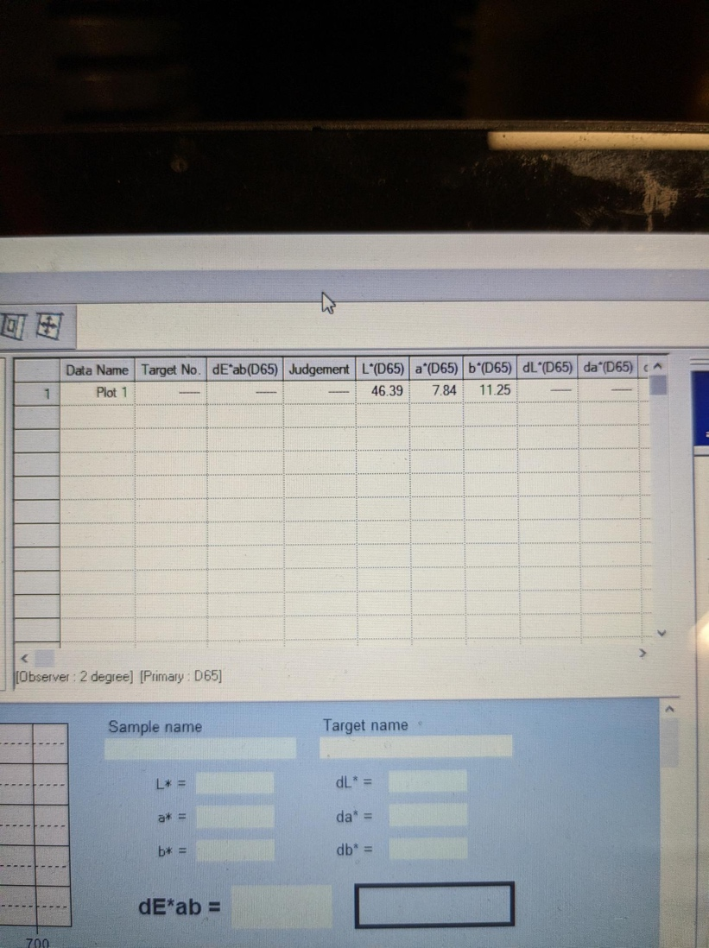After you press measure sample you can then change the name to the plot number:

Once you have taken the first measurement, you are ready to continue taking data! Just repeat steps 7 and 8, making sure to clean the lens gently with a Kim Wipe if it gets dusty, and saving the data occasionally to prevent any losses.

9. Cleaning up

* Once you have finished taking data for the day, turn the chromameter off and take out the RS-232C cable by pressing the small button on it that allows you to pull it out (don’t try to force it out!). Make sure that the cover is back on the instrument and the granular attachment is closed and clean.
* You can then finish up anything else on the software, make sure to save, then close it. Take out the USB key and make sure everything is in the box.

10. Exporting Data

* 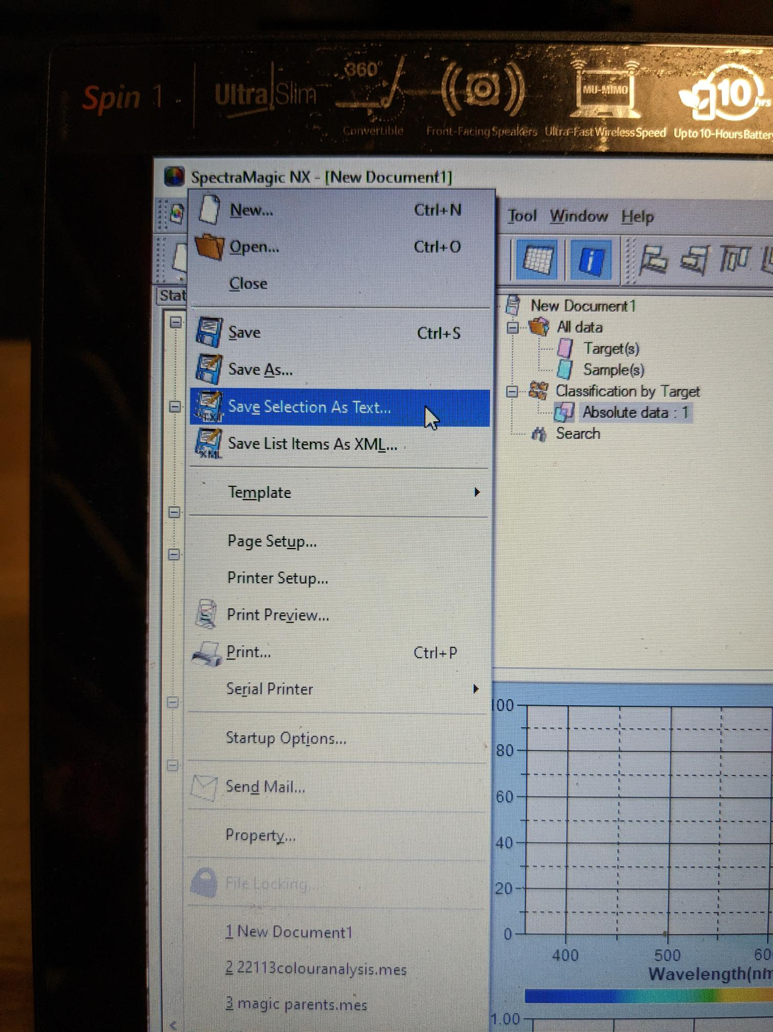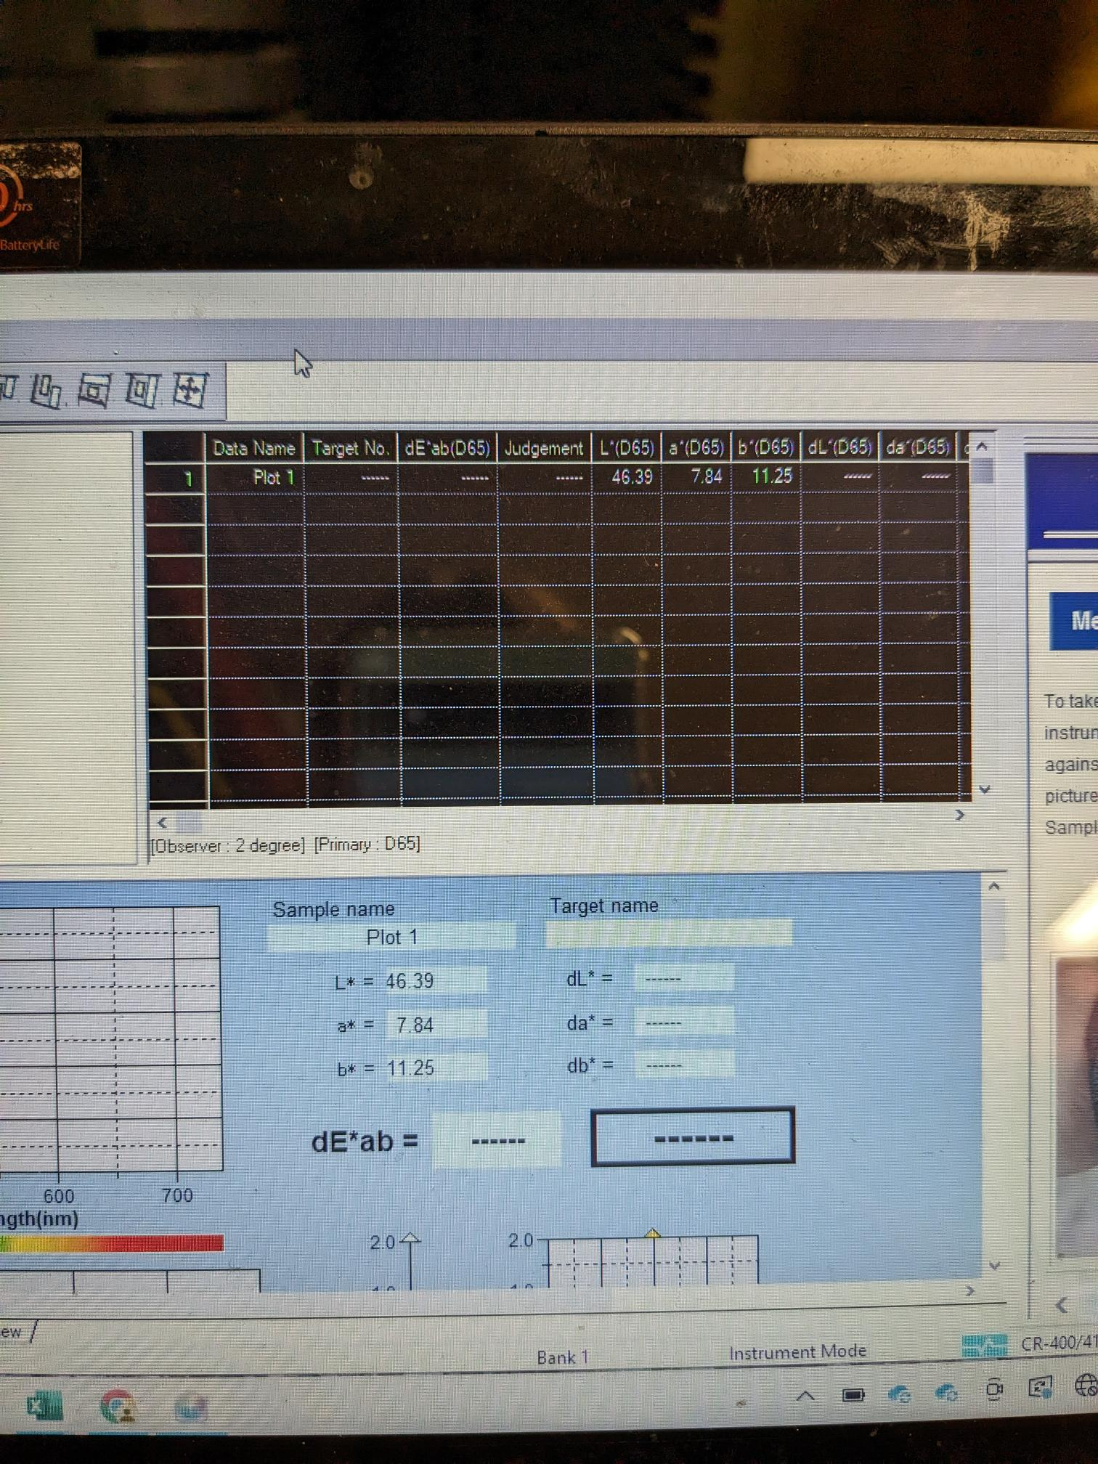Once all the data has been collected for a set of samples, it can be exported to excel. Select all the data by dragging from the top left corner down, then “save selection as text file” and save to desktop. Then you can drag the txt file into a new excel sheet and it will be properly formatted.

Additional resources

* [To reset the calibration data and illuminant](https://sensing.konicaminolta.us/us/learning-center/youtube/cr-400-and-410-chroma-meters-how-to-reset-illuminant/)